Continuous Automatic Control - CAC

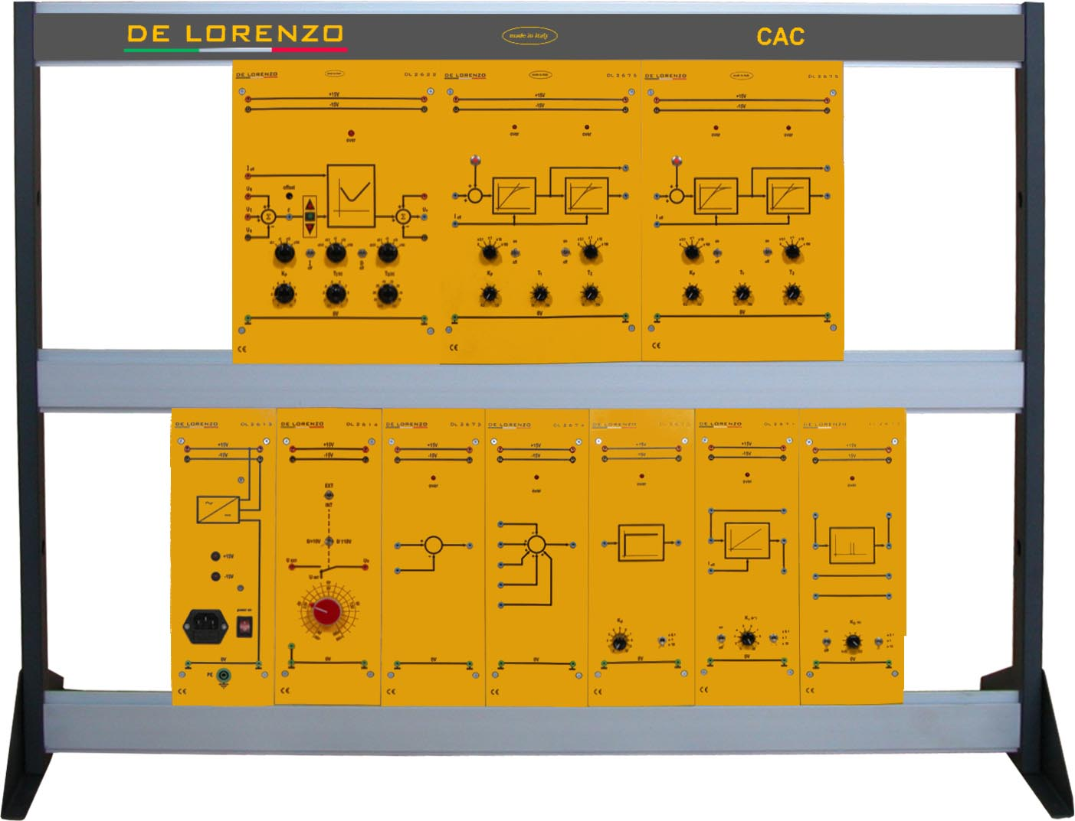

This laboratory is designed to study processes and controllers suitably combined to simulate and to study the most common problems related to Continuous Automatic Control. The analysis of the interactions between controllers and processes is complicated by the possible presence of noise; sometimes, the latter can trigger a series of oscillations with consequences, potentially serious, for the process. In this configuration, the student can study the causes of the above-mentioned instabilities, in order to find possible solutions.
This trainer has a modular structure and it consists of didactic panels installed on a vertical frame. It is supplied with a theoretical and practical manual. The modularity of this didactic system can give the students a direct and immediate approach to the topics, offering the opportunity to study various subjects, performing several experiments as follows:

- P control of a P type process
- P control of 1st, 2nd, 3rd and 4th order processes
- I control of 2nd order and I type processes
- P, PD, PI and PID controls of a high order process: stability and optimization
- P, PD, PI and PID controls of a high order process: presetting of the parameters according to Ziegler-Nichols (dynamic method)
- P, PD, PI and PID controls of a high order process: presetting of the parameters according to Chien-Hrones-Reswick (static method)
- P, PD, PI and PID controls of a high order process: parallel and series configuration
List of modules for experiments:
 |  | MODULES
 |  | DL 2613 | DL 2614 | DL 2622 | DL 2670 | DL 2671 | DL 2672 | DL 2673 | DL 2674 | DL 2675 | DL PS-MODE | DL PP-MODE | DL ACTSW | DL 1893 | DL 115ACT | DL 2100-3M
No | EXPERIMENT
1 | Regulation P, Process type P | 1 | 1 |  | 1 |  |  | 1 |  | 1 |  |  | 1 | 1 | 1 | 1
2 | Regulation P, Process of 1st order and superior | 1 | 1 | 1 |  |  |  |  |  | 2 |  | 1 | 1 | 1 | 1 | 1
3 | Regulation I, Process 2nd order | 1 | 1 |  |  | 1 |  | 1 |  | 1 |  | 1 | 1 | 1 | 1 | 1
4 | Regulation P, PD, PI e PID process of high order | 1 | 1 | 1 |  |  |  |  |  | 2 | 1 | 1 | 1 | 1 | 1 | 1
5 | Ziegler-Nichols method | 1 | 1 | 1 |  |  |  |  |  | 2 | 1 | 1 | 1 | 1 | 1 | 1
6 | Chien-Hrones-Reswick static method | 1 | 1 | 1 |  |  |  |  |  | 2 | 1 | 1 | 1 | 1 | 1 | 1
7 | Parallel and series configuration | 1 | 1 |  | 1 | 1 | 1 | 1 | 1 | 2 |  | 1 | 1 | 1 | 1 | 1
8 | TOTAL | 1 | 1 | 1 | 1 | 1 | 1 | 1 | 1 | 2 | 1 | 1 | 1 | 1 | 1 | 1

